The National Art School would like to announce the 2024 Dobell Regional Teachers’ Workshop: A Visual Arts project for teachers in regional NSW funded by the Sir William Dobell Art Foundation.

The 2024 Dobell Regional Teachers’ Workshop offers up to 18 places for Government School Visual Arts teachers to engage in an intensive drawing workshop. The workshops will function on a yearly rotating regional system whereby a different NSW area is targeted each year and held at a central location.
.
This is a unique opportunity to work with a practicing artist from the National Art School (NAS) in this 2-day workshop. On day one participating Visual Art teachers will engage in six hours of intensive professional development in drawing within the studio-based tradition of NAS. Day two will focus on strategies for facilitating drawing-based collaboration in the classroom. Throughout the workshop participants will be encouraged to share ideas and debate issues with peers while exploring the technical and conceptual directions of their work.

Course Details
Title Drawn together: practical techniques for expressive and collaborative drawings in the classroom
Tutor Luke Thurgate
Dates Saturday 16 and Sunday 17 November 9am-4pm
Venue Glasshouse, Port Macquarie
Participants 25
Cost Free – workshop fees generously covered by the Sir William Dobell Art Foundation. Participants are to cover their own travel and accommodation costs.
NESA Accreditation
Completing Dobell Regional Teachers’ Workshop will contribute 12 hours of NSW Education Standards Authority (NESA) Accredited PD in the priority area of Delivery and assessment of NSW Curriculum/Early Years Learning Framework addressing standard descriptors 2.1.2, 2.2.2, 3.3.2, 3.4.2 from the Australian Professional Standards for Teachers towards maintaining Proficient Teacher Accreditation in NSW.

Course Outline
Create a toolkit of drawing techniques and develop strategies for encouraging collaboration in the classroom. The workshop is a two-day intensive ‘boot camp’ for teachers acting as both a refresher in drawing skills and a chance to build new approaches to group work. This workshop will start with a series of exercises to extend understanding of the drawing medium. We will focus on developing confidence in the fundamentals of observational drawing, whilst focusing on process and experimentation. Teachers will approach drawing with the intention of understanding drawing as more than just the creation of an image on a surface. They will learn new approaches for liberated mark making, taking risks, felt perception, and developing new skills in a fun and fast-moving workshop. The Sunday session will begin with a discussion of collaboration in historical and contemporary art practice. Teachers will then test a range of group drawing exercises designed to encourage risk-taking, problem-solving and play.

What to bring:
All materials will be supplied. Please bring your own lunch each day.

Luke Thurgate Biography
Luke Thurgate is an artist living and working on Gadigal Land (Sydney). He teaches drawing and painting at the National Art School, where he graduated in 2021 with a Master of Fine Art. He has worked with educators and students for over two decades, having previously held public program roles at Adelaide Central School of Art, Art Gallery of South Australia and Newcastle Art Gallery. Having grown up in a small town on the far north coast of New South Wales, Luke is particularly passionate about working with regional audiences.
Luke’s extensive exhibition history includes recent projects at Grafton Regional Gallery, Maitland Regional Art Gallery, Backwoods Gallery, Burra Regional Art Gallery, National Art School, and Adelaide Central Gallery. He was a finalist in the 2019 and 2023 Dobell Drawing Prize, the 2022 Jacaranda Acquisitive Drawing Award, and the 2020 Tom Bass Figurative Sculpture Prize. Luke is represented in NSW by M. Contemporary.
Luke’s multi-disciplinary studio practice explores the construction and deconstruction of identity in relation to romance, power, and otherness. Working across drawing, painting, sculpture and performance, his work appropriates the signifying capacity of the western canon, referencing processes, materials and imagery from Renaissance and Baroque art making.
Luke’s current work uses the monster as a surrogate ’other’ to explore tensions between parody, sincerity, menace, pathos, transgression, and vulnerability. Informed by a range of sources, including popular culture, and Catholic iconography, his practice transcribes the western canon through a lens of queer aesthetics and subjectivity.
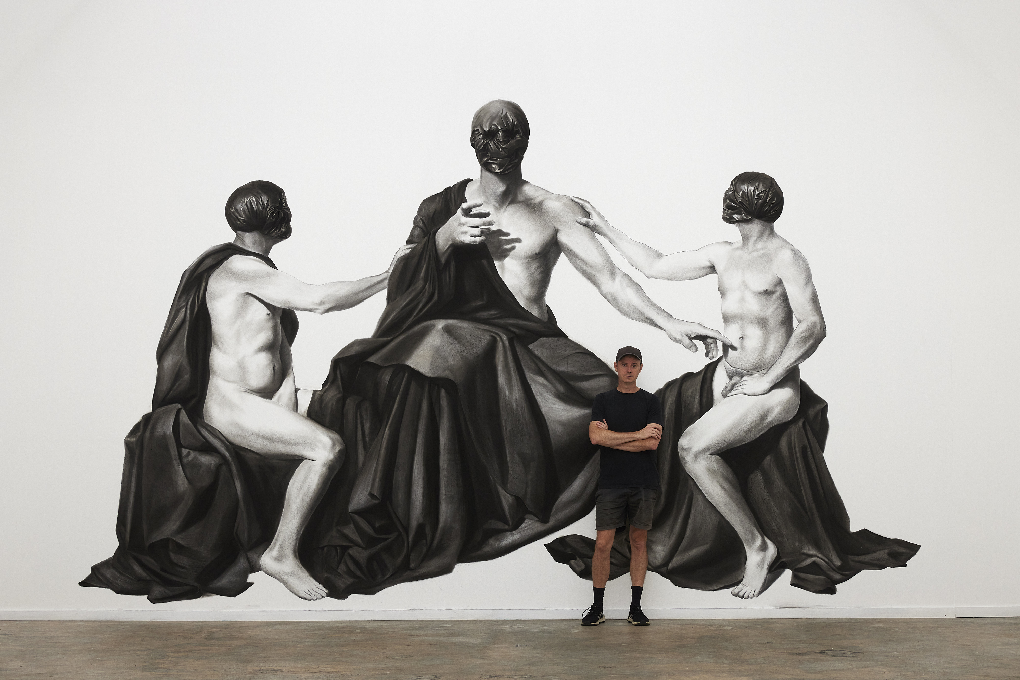
Installation shot from Adore you, 2023, The Drawing Gallery, National Art School. Photo by Tim Connolly.

Please fill in the registration form here by Monday 21 October.

If you have any questions about the workshop, please contact:

Cecilia Jackson
Education Coordinator
National Art School
T: 9339 8751
cecilia.jackson@nas.edu.au

You will receive confirmation of registration via email by Friday 25 October.
Precedence will be given to applications in order of receipt.

